Lab 6 :- Advanced Programs Using Structure and Union
- Define a structure called Players which describe details like p_name, team, score, average. Write a program to read data for 3 players and print that data.

#include <stdio.h>
#include <string.h>

struct Players {
char p_name[50];
char team[50];
int score;
float average;
};

int main() {
struct Players players[3];

for (int i = 0; i < 3; i++) {
printf("Enter details for player %d:\n", i + 1);
printf("Player Name: ");
getchar();
gets(players[i].p_name);
printf("Team: ");
gets(players[i].team);
printf("Score: ");
scanf("%d", &players[i].score);
printf("Average: ");
scanf("%f", &players[i].average);
}

printf("\nPlayer Details:\n");
for (int i = 0; i < 3; i++) {
printf("Player %d:\n", i + 1);
printf("Name: %s\n", players[i].p_name);
printf("Team: %s\n", players[i].team);
printf("Score: %d\n", players[i].score);
printf("Average: %.2f\n", players[i].average);
printf("\n");
}

return 0;
}

Output:-
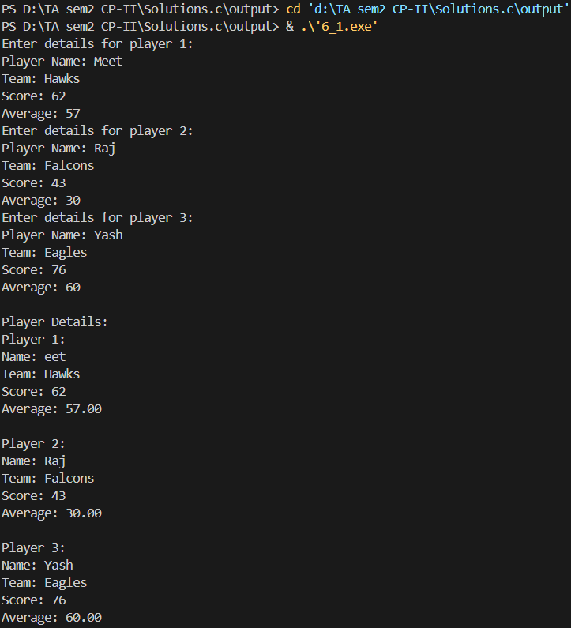

- Define a union called Players which describe details like p_name, team, score, average. Write a program to read data for 3 players and print that data.

#include <stdio.h>
#include <string.h>

union Players {
char p_name[50];
char team[50];
int score;
float average;
};

int main() {
union Players player;
char names[3][50], teams[3][50];
int scores[3];
float averages[3];

for (int i = 0; i < 3; i++) {
printf("Enter details for player %d:\n", i + 1);
printf("Player Name: ");
getchar();
gets(names[i]);
printf("Team: ");
gets(teams[i]);
printf("Score: ");
scanf("%d", &scores[i]);
printf("Average: ");
scanf("%f", &averages[i]);
}

printf("\nPlayer Details:\n");
for (int i = 0; i < 3; i++) {
printf("Player %d:\n", i + 1);
printf("Name: %s\n", names[i]);
printf("Team: %s\n", teams[i]);
printf("Score: %d\n", scores[i]);
printf("Average: %.2f\n", averages[i]);
printf("\n");
}

return 0;
}

Output:-
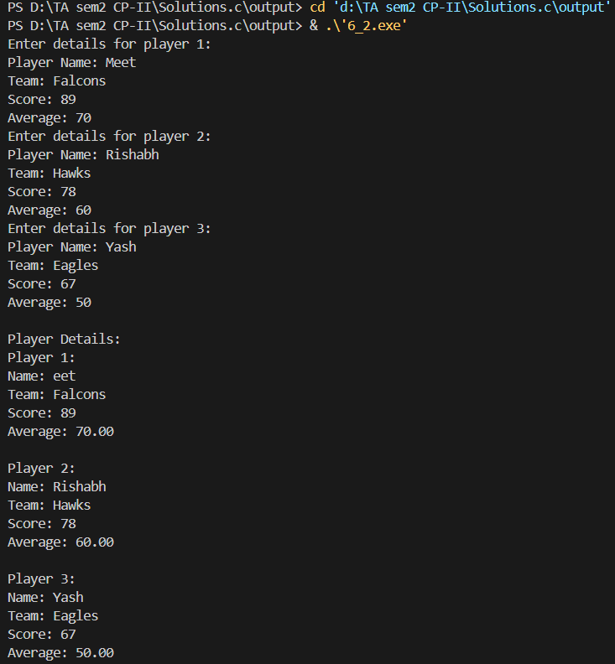

- Define a structure called Players which describe details like p_name, team, score, average. Write a program to read data for N players and arrange p_name in alphabetical order.

#include <stdio.h>
#include <string.h>

struct Players {
char p_name[50];
char team[50];
int score;
float average;
};

int main() {
int n;
struct Players temp;

printf("Enter the number of players: ");
scanf("%d", &n);

struct Players players[n];

for (int i = 0; i < n; i++) {
printf("Enter details for player %d:\n", i + 1);
printf("Player Name: ");
getchar();
gets(players[i].p_name);
printf("Team: ");
gets(players[i].team);
printf("Score: ");
scanf("%d", &players[i].score);
printf("Average: ");
scanf("%f", &players[i].average);
}

for (int i = 0; i < n - 1; i++) {
for (int j = i + 1; j < n; j++) {
if (strcmp(players[i].p_name, players[j].p_name) > 0) {
temp = players[i];
players[i] = players[j];
players[j] = temp;
}
}
}

printf("\nPlayer Details Sorted by Name:\n");
for (int i = 0; i < n; i++) {
printf("Player %d:\n", i + 1);
printf("Name: %s\n", players[i].p_name);
printf("Team: %s\n", players[i].team);
printf("Score: %d\n", players[i].score);
printf("Average: %.2f\n", players[i].average);
printf("\n");
}

return 0;
}

Output:-
